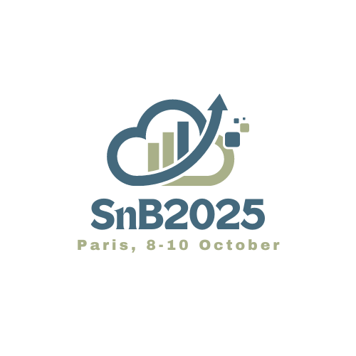

***”Advancing drug development through innovative designs and efficient data use”***

***Sponsorship & Exhibition Opportunities***



Become a SnB Sponsor

The SnB2025 Conference organized by the Statistics and Biopharmacy group of the SFdS (French Society of Statistics) will be held in Paris 8-10 October 2025. It is a unique event, usually organized every four years, integrating multiple perspectives on innovative applied statistical research for the drug development and an excellent opportunity to meet colleagues from academia, regulatory agencies and pharmaceutical companies.

Therefore, the SnB Conference is an excellent opportunity to:

* keep up to date with the needs of scientists and clinical researchers from all over the world,
* present your products and services,
* support scientific research.

Within this brochure, you will find many opportunities to sponsor the **SnB2025** Conference. We would also welcome any additional suggestions for supporting the conference.

**Exhibition space reservations are based on first come first served basis.**

[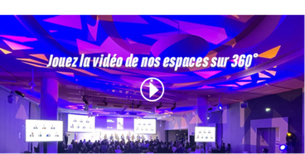](https://eur01.safelinks.protection.outlook.com/?url=https%3A%2F%2Fcloud.letsignit.com%2Fcollect%2Fb%2F63b58995a1b67482c76b38a8%3Fp%3D1n6-IdOBz_8GOFoqH2cQlACjf96Kpby2glUXyH4HuA-uxEJEwq8Tlr8mNbvKssQoSoBQNiHnhl-R4lG2iN-qvLloN0w4xesRTCYUAymKK5mBiOsyK5odmINK1IeEpuGTK56scIcuvKb6SpnlQgDjuRSCrkfTrd--_PS9cbivAuo%3D&data=05%7C02%7Cestelle.lambert%40servier.com%7C68aebf67445844ee35c208dcb22d1abd%7Ccc0a4ff694544e4b881b85f448dee2e3%7C0%7C0%7C638581154002178652%7CUnknown%7CTWFpbGZsb3d8eyJWIjoiMC4wLjAwMDAiLCJQIjoiV2luMzIiLCJBTiI6Ik1haWwiLCJXVCI6Mn0%3D%7C0%7C%7C%7C&sdata=bq8fvj0MOazKNf651SaqOegOHrHQAQS7d2%2Bc1GqEfm8%3D&reserved=0)

|  |  |  |  |
| --- | --- | --- | --- |
|  | Sponsorship opportunities | | |
|  | *GOLD*  *6,000€*  *limited to 2 companies* | *SILVER*  *3,500€*  *limited to 8 companies* | *BRONZE*  *1000€* |
| logo with a link to your company’s website on the official conference WEBSITE | Size 3 | Size 2 | Size 1 |
| logo on the conference app | Size 3 | Size 2 | Size 1 |
| logo projected between plenary sessions | Size 3 | Size 2 | Size 1 |
| Exhibition stand | Longer exhibition stand (3 x 1.5m) ensuring excellent footfall | Single stand (150 x 80cm) in the exhibition area | ----------------- |
| Complimentary standard REGISTRATION | For 4 people | For 2 people | ----------------- |
| Complimentary conference DINNER | For 4 people | ----------------- | ----------------- |
| Conference BAG inserts (*to be provided by Sponsor*) | Opportunity to distribute a leaflet in the conference bags | ----------------- | ----------------- |

|  |  |  |  |
| --- | --- | --- | --- |
|  | Other Exclusive sponsorship opportunities | | |
| SnB BAGS  (3,000€) -  Company logo on the front of the conference bag given to every attendee. | BADGE LANYARD  (2,500€)  *Supplied by the sponsor*  Your logo will be displayed on lanyards used by attendees. | SnB Notepad  (2,500€) -  *Supplied by the sponsor*  A notepad with your logo on it will go into every attendee bag. | SnB PEN  (2,500€) -  *Supplied by the sponsor*  A pen with your logo on it will go into every attendee bag. |
| LEAFLET OR GIVEAWAY (1,500€)  limited to 5  *Supplied by the sponsor*  Promotional material (not exceeding 2 A4 pages) or Promotional item (e.g. t-shirt…) inserted into the conference bags. |  |  |  |

Payment & deposit

All sponsorship items are listed in Euros and not subject to VAT. Total fee is requested at the reservation excepted for sponsorship of at least 3,000€ where 50% of the fee is requested to secure the reservation with the balance to be paid by May 1st, 2025. Sponsorship items bought after this date must be paid in full at the time of booking.

**Have a great another sponsoring idea? Let us know by emailing us: estelle.lambert@servier.com**